Date: 01/02/2018

University/Academic Institution: Sandip University Course Name: M.Tech ACDS

Batch Name: 2017-19 Module Name: Advanced Data Structures

Pre -Assignment: (All programs to be committed via git only)

**POINTER PROGRAM 1:**

**CODE:**

#include <iostream>

using namespace std;

int main()

{

int *pc, c;

c = 5;

cout << "Address of c (&c): " << &c << endl;

cout << "Value of c (c): " << c << endl << endl;

pc = &c; // Pointer pc holds the memory address of variable c

cout << "Address that pointer pc holds (pc): "<< pc << endl;

cout << "Content of the address pointer pc holds (*pc): " << *pc << endl << endl;

c = 11; // The content inside memory address &c is changed from 5 to 11.

cout << "Address pointer pc holds (pc): " << pc << endl;

cout << "Content of the address pointer pc holds (*pc): " << *pc << endl << endl;

*pc = 2;

cout << "Address of c (&c): " << &c << endl;

cout << "Value of c (c): " << c << endl << endl;

return 0;

}

**OUTPUT:**

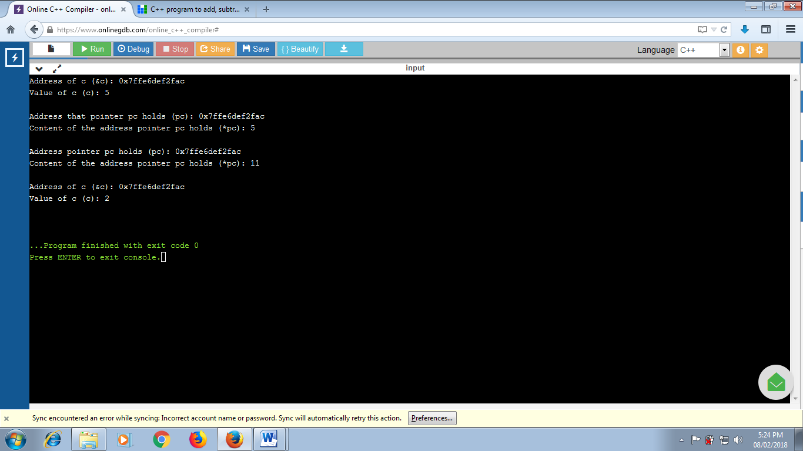

**POINTER PROGRAM 2:**

**CODE:**

#include <iostream>

using namespace std;

int main ()

{

int var1;

char var2[10];

cout << "Address of var1 variable: ";

cout << &var1 << endl;

cout << "Address of var2 variable: ";

cout << &var2 << endl;

return 0;

}

**OUTPUT:**

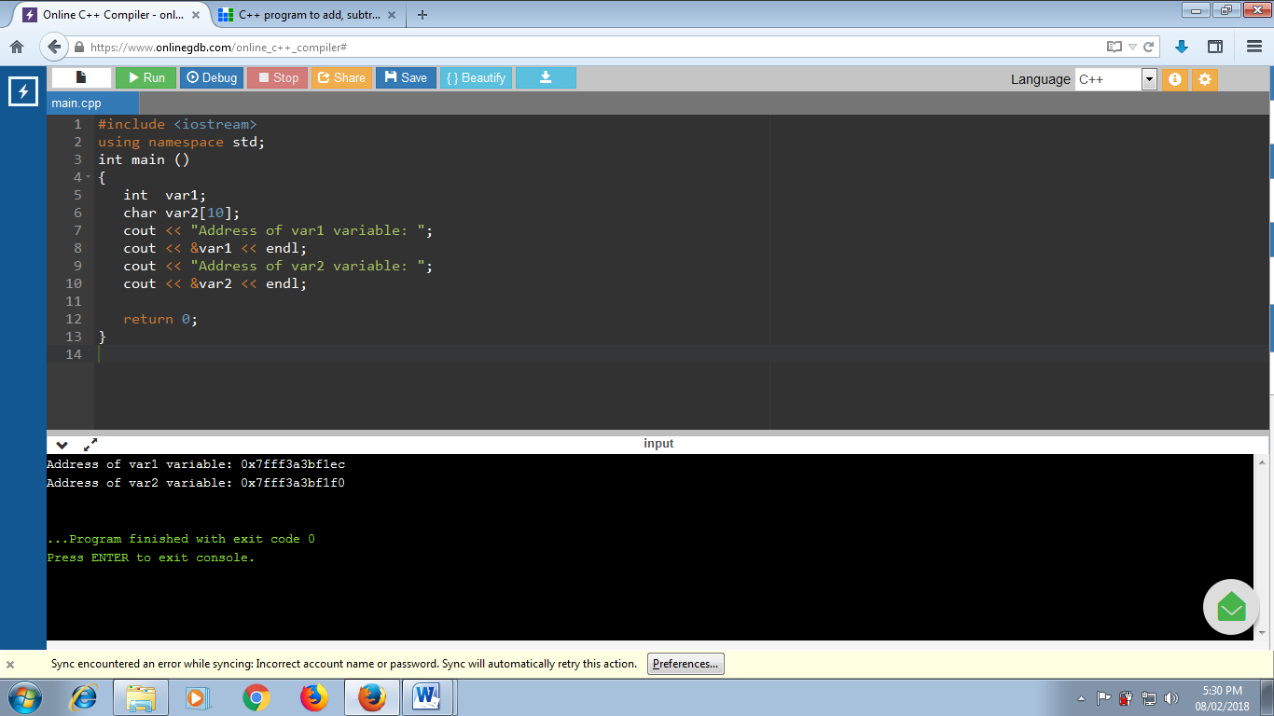

**STRUCTURE 1:**

**CODE:**

#include <iostream>

using namespace std;

struct Person

{

char name[50];

int age;

float salary;

};

int main()

{

Person p1;

cout << "Enter Full name: ";

cin.get(p1.name, 50);

cout << "Enter age: ";

cin >> p1.age;

cout << "Enter salary: ";

cin >> p1.salary;

cout << "\nDisplaying Information." << endl;

cout << "Name: " << p1.name << endl;

cout <<"Age: " << p1.age << endl;

cout << "Salary: " << p1.salary;

return 0;

}

**OUTPUT:**

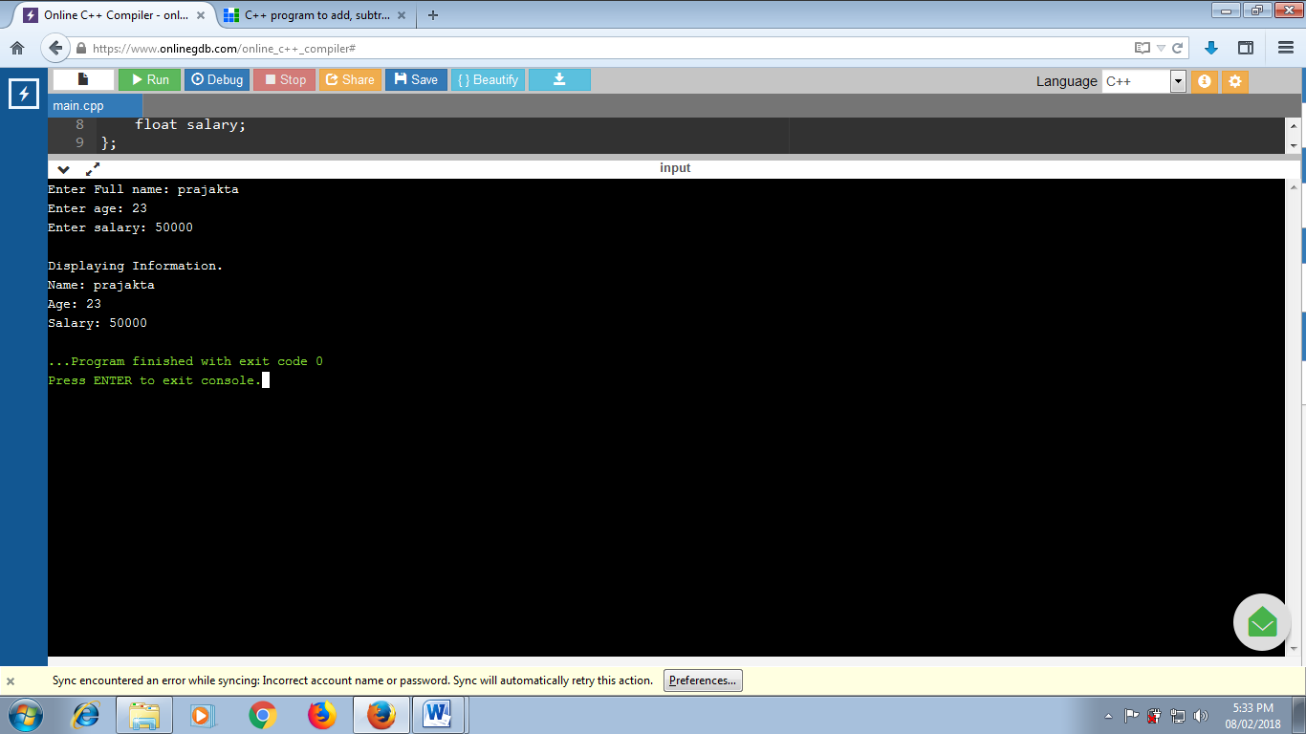

**STRUCTURE 2:**

**CODE:**

#include <iostream>

using namespace std;

struct Person

{

char name[50];

int age;

float salary;

};

void displayData(Person); // Function declaration

int main()

{

Person p;

cout << "Enter Full name: ";

cin.get(p.name, 50);

cout << "Enter age: ";

cin >> p.age;

cout << "Enter salary: ";

cin >> p.salary;

displayData(p);

return 0;

}

void displayData(Person p)

{

cout << "\nDisplaying Information." << endl;

cout << "Name: " << p.name << endl;

cout <<"Age: " << p.age << endl;

cout << "Salary: " << p.salary;

}

**OUTPUT:**

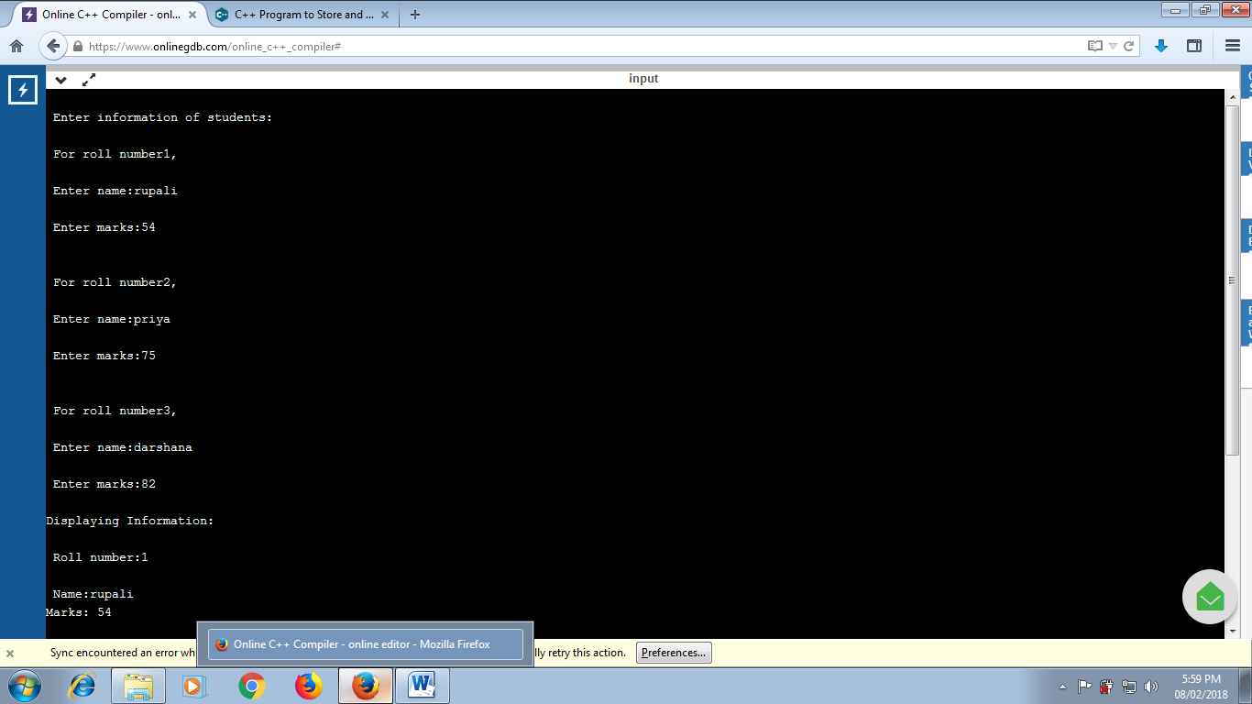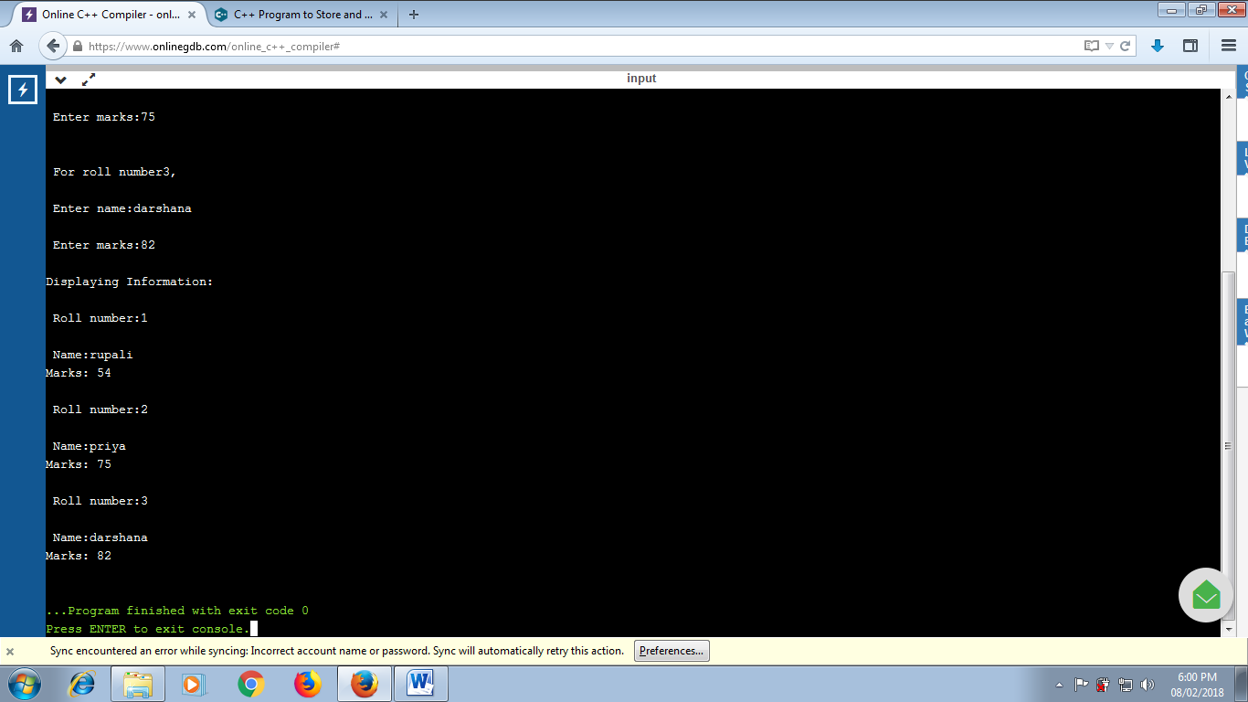

**INHERITANCE 1:**

**CODE:**

#include <iostream>

using namespace std;

class A

{

public:

void Afun(void);

};

class B:public A

{

public:

void Bfun(void);

};

void A::Afun(void)

{

cout<<"\n I'm the body of Afun()"<<endl;

}

void B::Bfun(void)

{

cout<<"\n I'm the body of Bfun()"<<endl;

}

int main()

{

B objB;

objB.Afun();

objB.Bfun();

return 0;

}

**OUTPUT:**

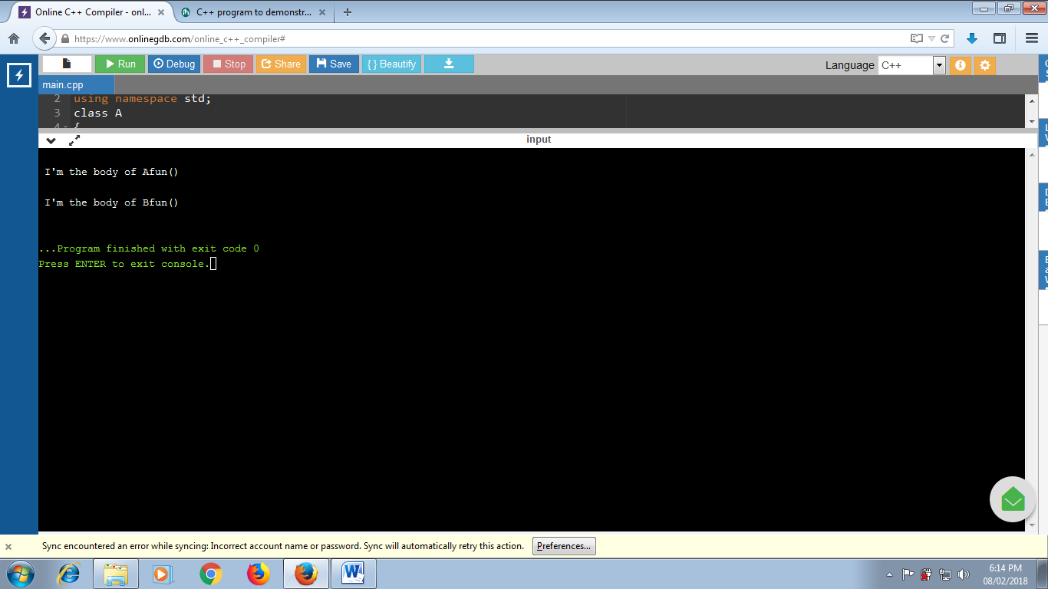

**INHERITANCE 2:**

**CODE:**

#include <iostream>

using namespace std;

class A

{

private:

int a;

public:

void get_a(int val_a)

{

a=val_a;

}

void put_a(void)

{

cout<<"value of a:"<<a<<endl;

}

};

class B

{

private:

int b;

public:

void get_b(int val_b)

{

b=val_b;

}

void put_b(void)

{

cout<<"value of b:"<<b<<endl;

}

};

class C

{

private:

int c;

public:

void get_c(int val_c)

{

c=val_c;

}

void put_c(void)

{

cout<<"value of c:"<<c<<endl;

}

};

class final:public A,public B,public C

{

public:

void printValues(void)

{

put_a();

put_b();

put_c();

}

};

int main()

{

final objFinal;

objFinal.get_a(1000);

objFinal.get_b(2000);

objFinal.get_c(3000);

objFinal.printValues();

return 0;

}

**OUTPUT:**

